# 4 Design Chapter

This chapter will focus on what is important to consider in the design process. The system architecture and the UI (User Interface). This project was developed using the Unity Engine, Visual Studio Code and Photoshop. In the System Architecture section, the user’s interaction with the application is described. In the User Interface Design section, the UI sketches and high-fidelity versions of the sketches are shown. There is inspiration from similar games. In the Proposed Map Layout section, the map sketches and high-fidelity versions are shown.

## 4.1 System Architecture

### User Flow

When designing a game, the developer must think about how the user will move through the application. The developer must understand what the user will find irritating but also what the user will like and appreciate.

**Figure 1** shows how the user will interact with the main menu. The user has 3 options to pick from:

* The player can select the “Play Game” button, this starts the game at the first level.
* The player can select the “Settings” button, this opens the settings menu where the user can choose to change the audio or video settings.
* The player can select the “Quit” button, this closes the application.

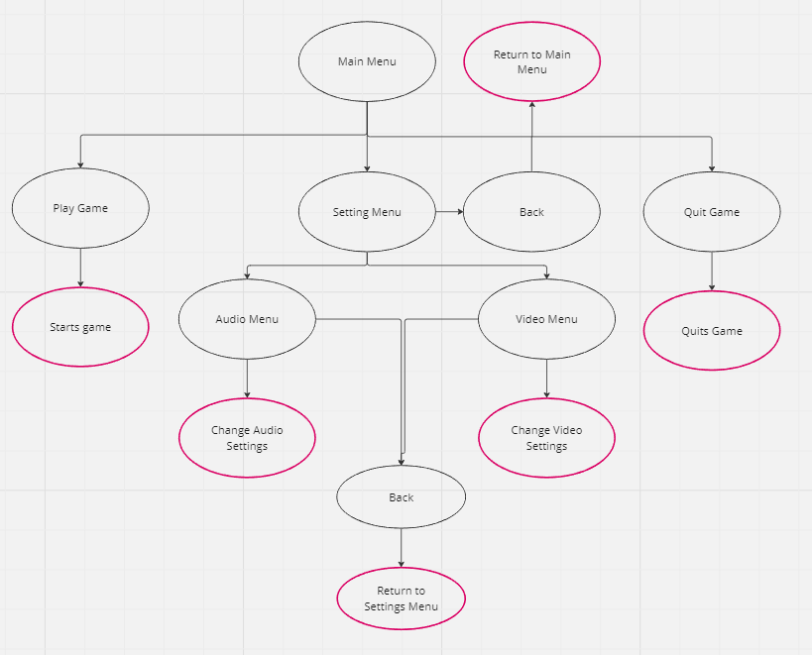

Figure Main Menu User Flow Diagram

**Figure 2** shows how the user will interact with the pause menu. When the player presses the “Pause” button the game is paused. The player is then shown the pause menu. The player has 3 options to choose from:

* The “Resume” button, this resumes the game and hides the pause menu.
* The “Settings” button, this displays the settings menu where the user can change the audio or video settings.
* The “Quit” button, this returns the player to the main menu.

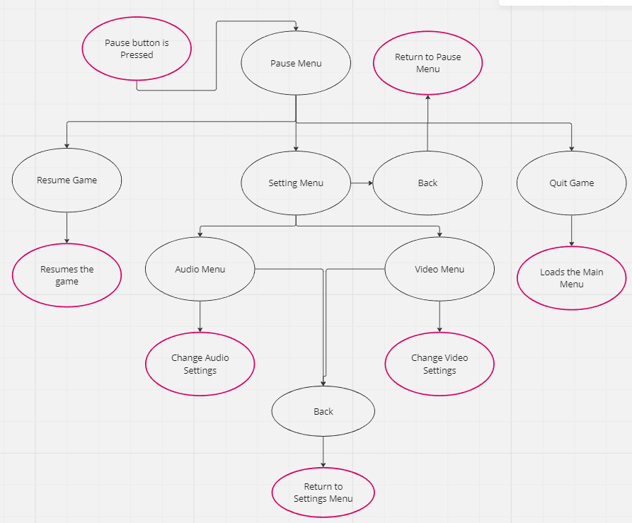

Figure Pause Menu User Flow Diagram

**Figure 3** shows how the user will interact with the death menu. This is shown when the player dies. The player has two options:

The “Quit” button, this returns the user to the main menu.

The “Restart” button, this will restart the current scene.

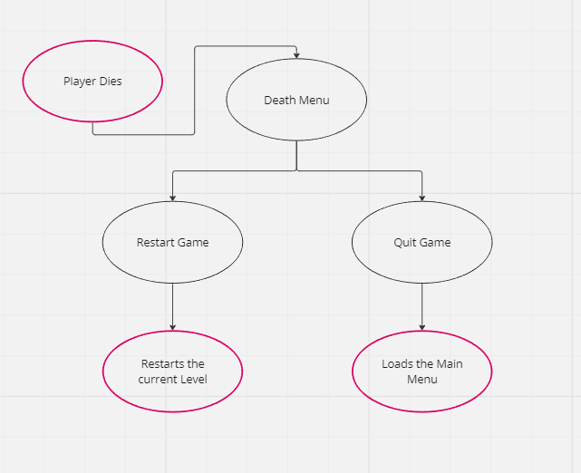

Figure Death Menu User Flow Diagram

## 4.2 User Interface Design

**Figures 4 – 9** show the author’s sketches for what they want the menus to look like.

Figure Start Menu sketch

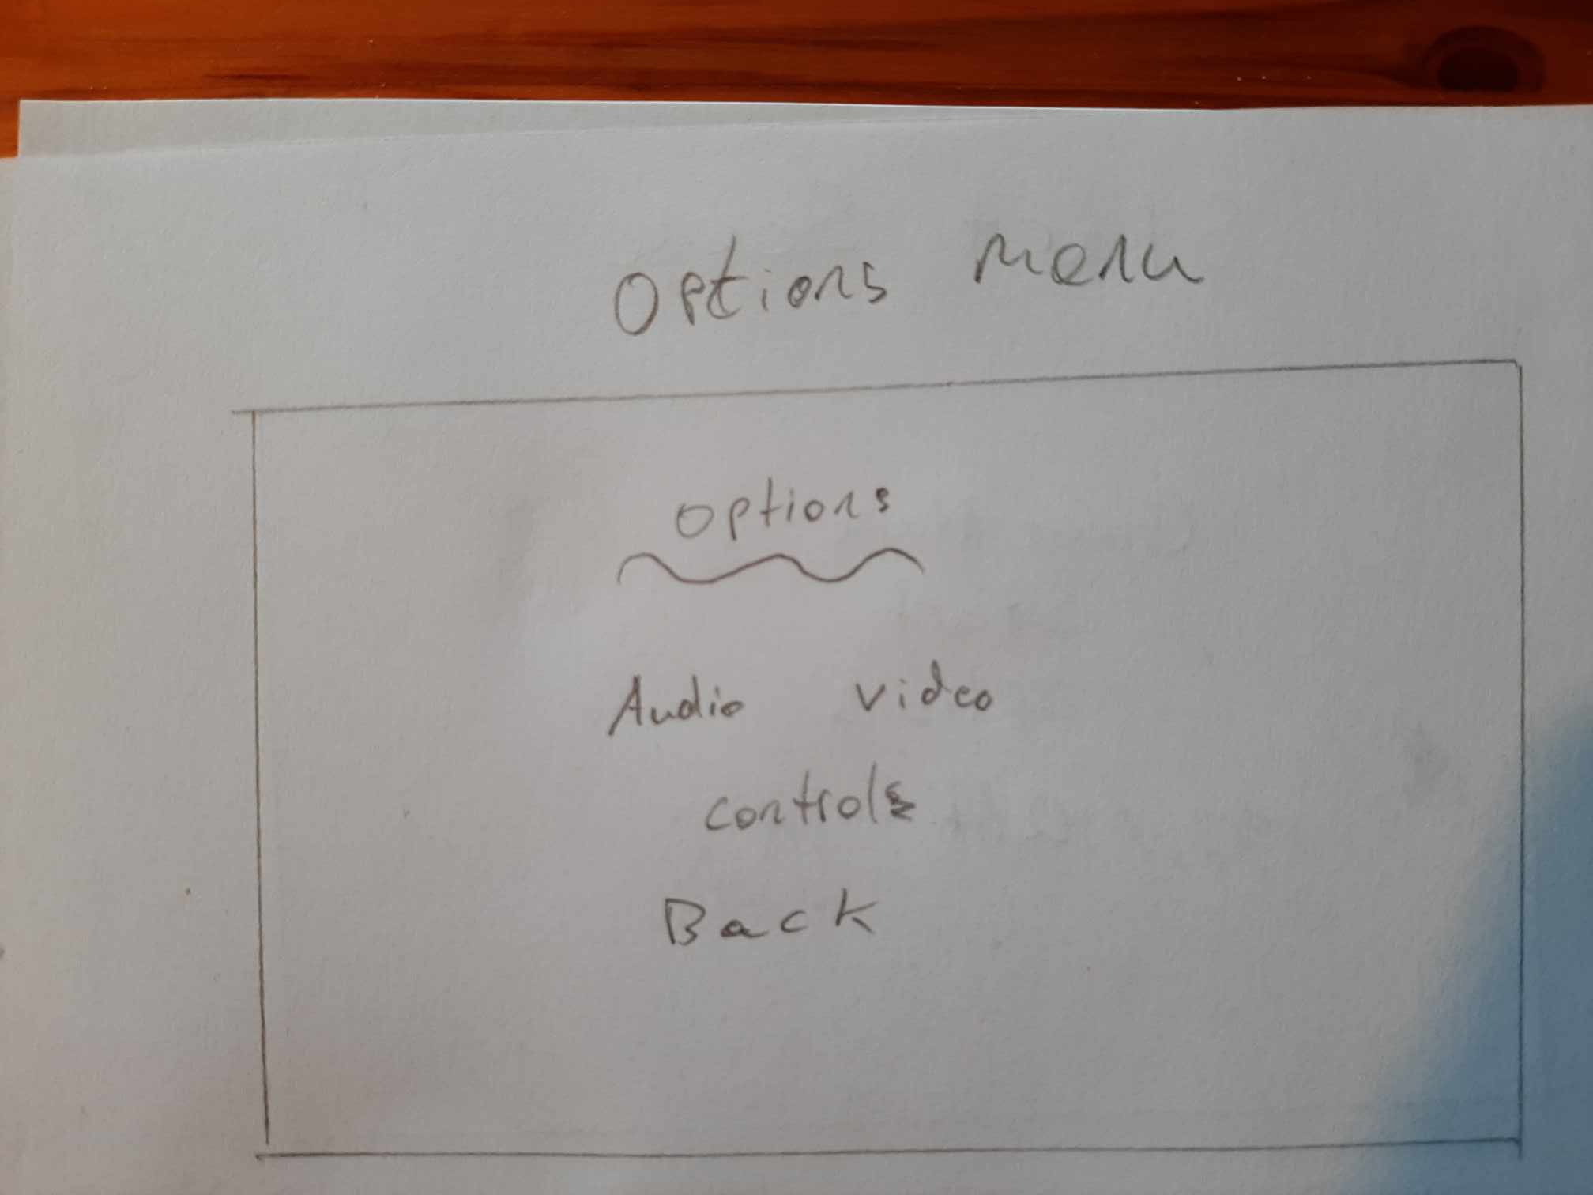

Figure Options Menu sketch

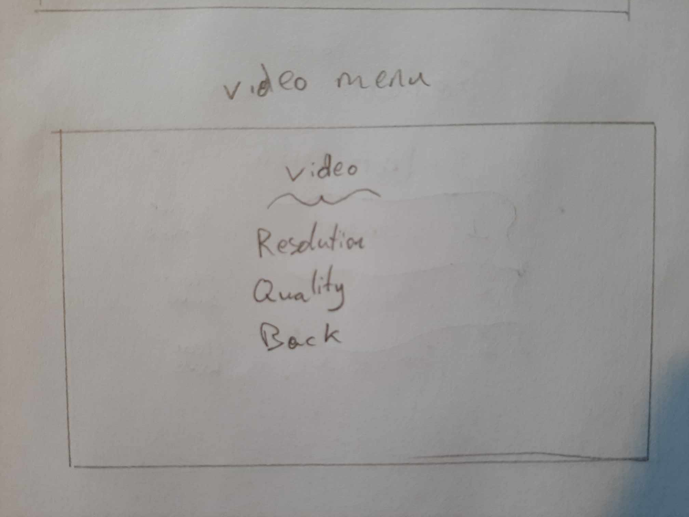

Figure Video Menu sketch

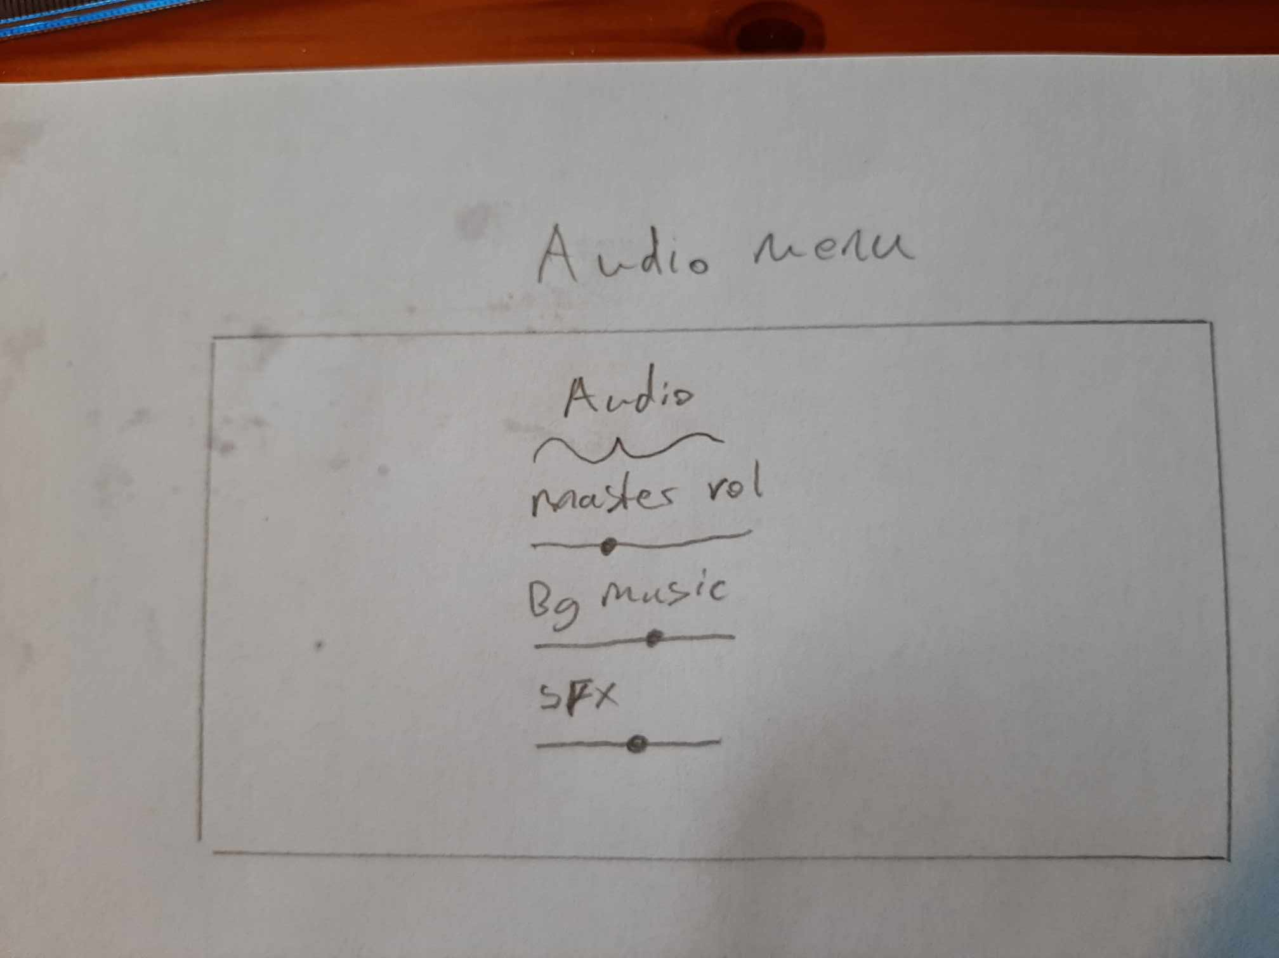

Figure Audio Menu sketch

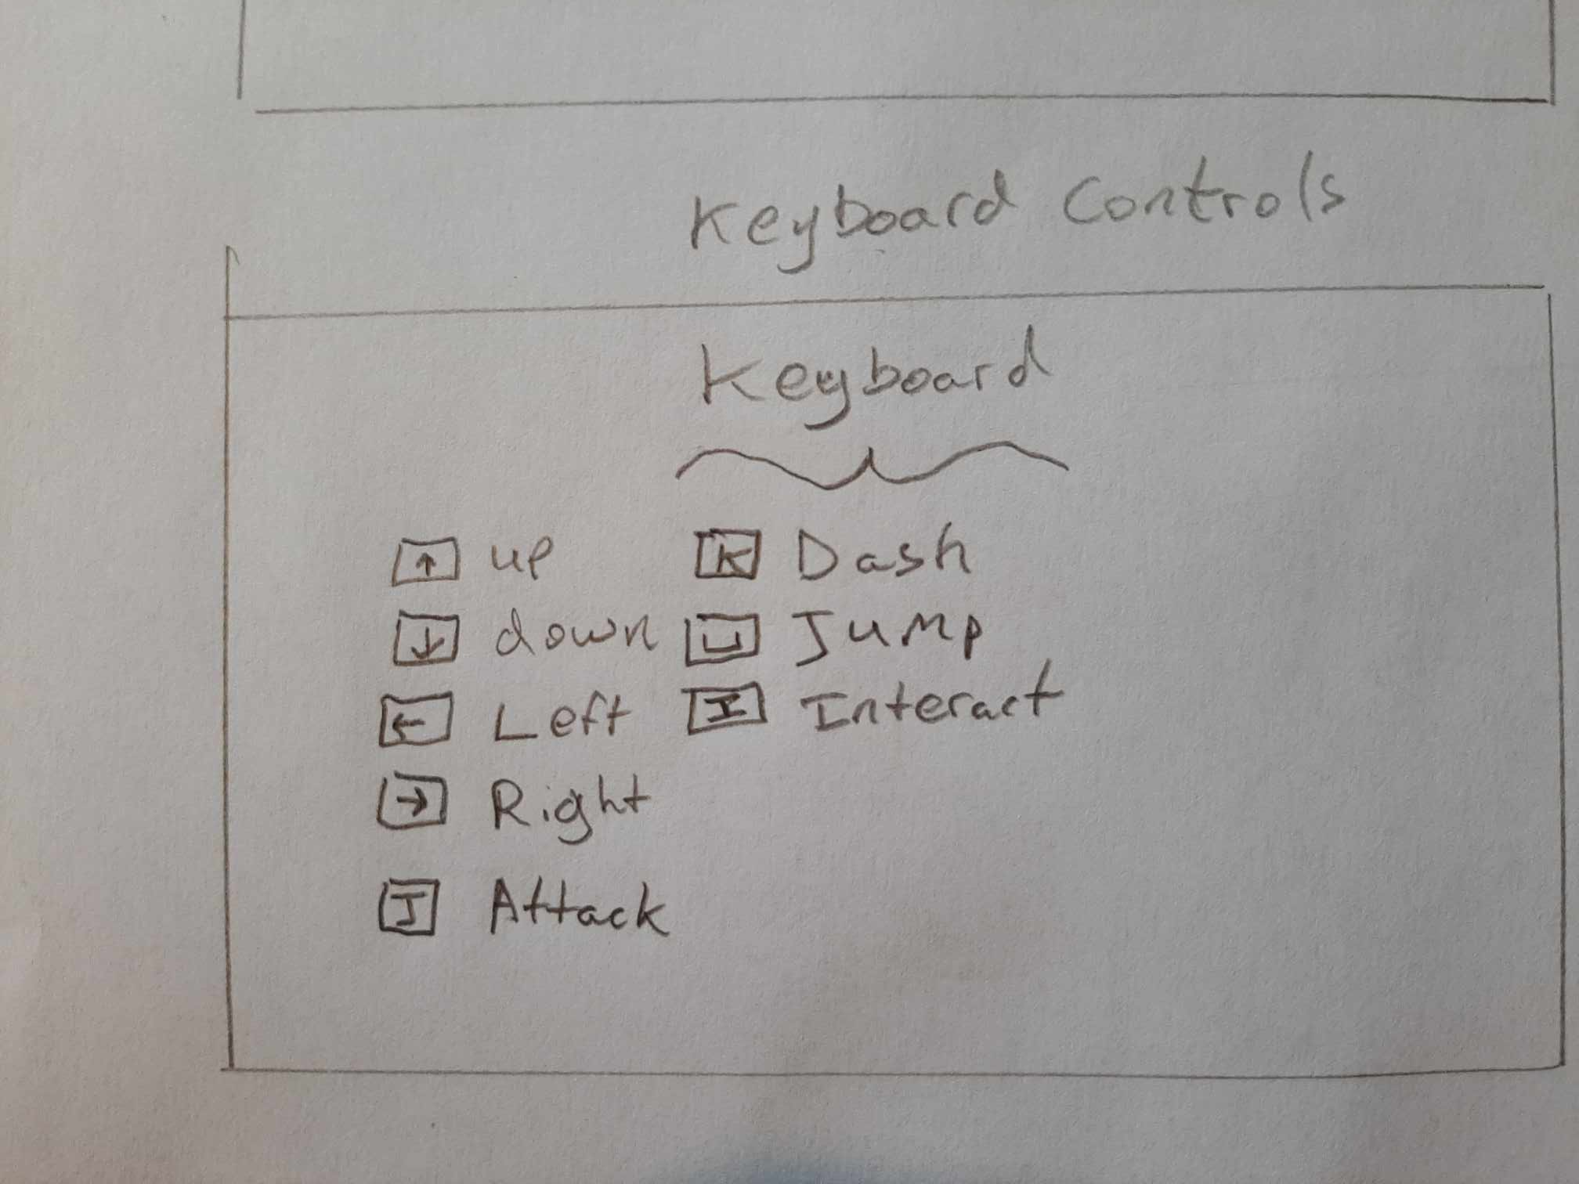

Figure Keyboard Menu sketch

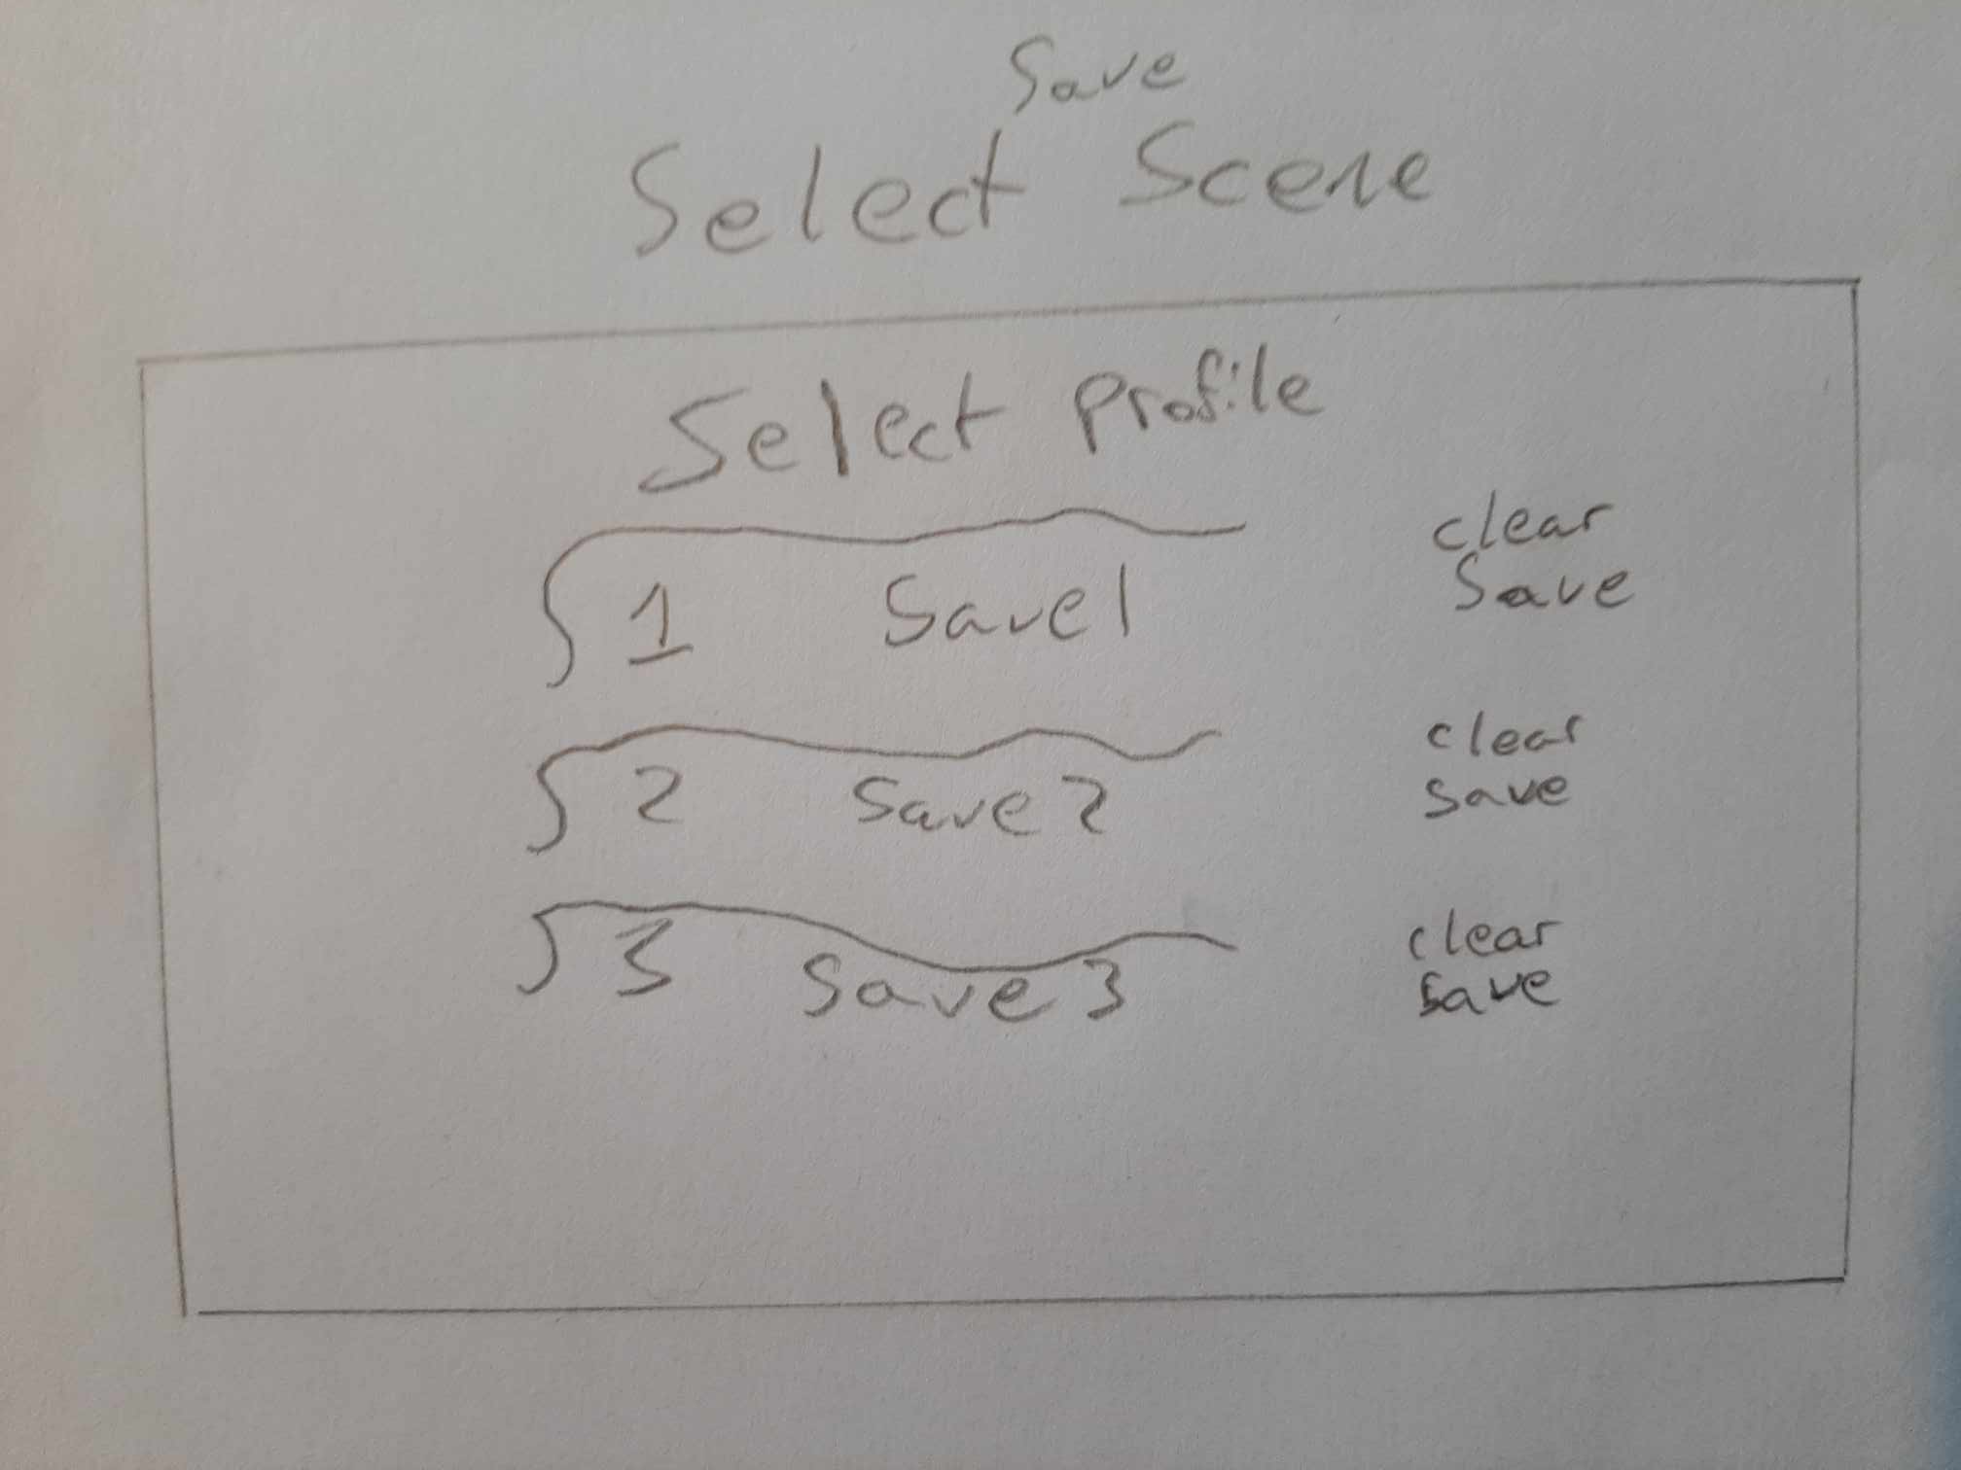

Figure Select Save Menu sketch.

**Figures 10 – 15** show the author’s developed versions of the menus.

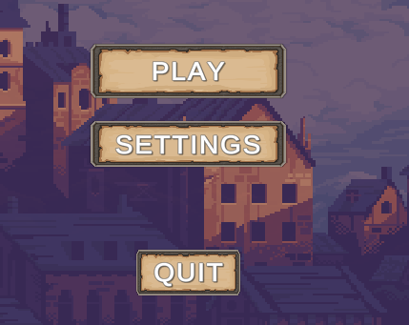

Figure Main Menu

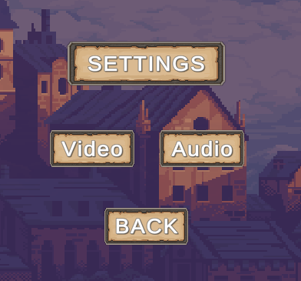

Figure Settings Menu

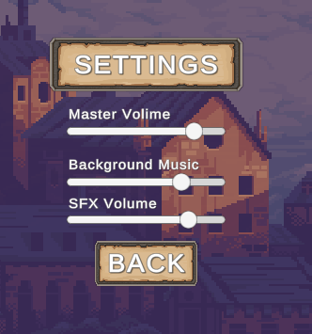

Figure Settings Menu Audio

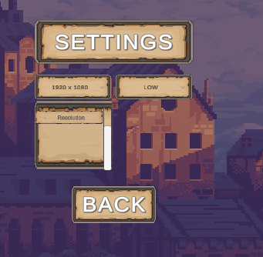

Figure Settings Menu Video

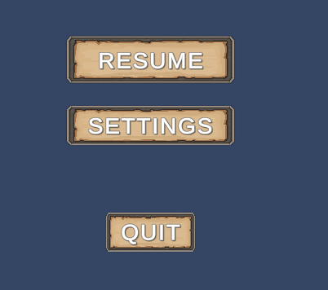

Figure Pause Menu

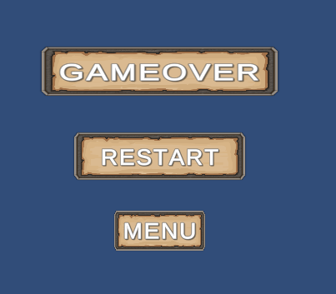

Figure Death Menu

### 4.2.1 Inspiration

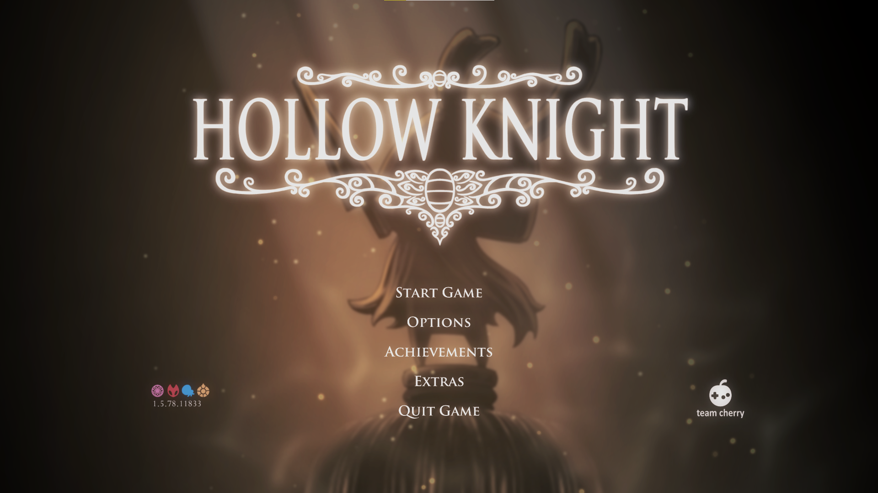

Figure : Screenshot taken by the author showing the Menu UI

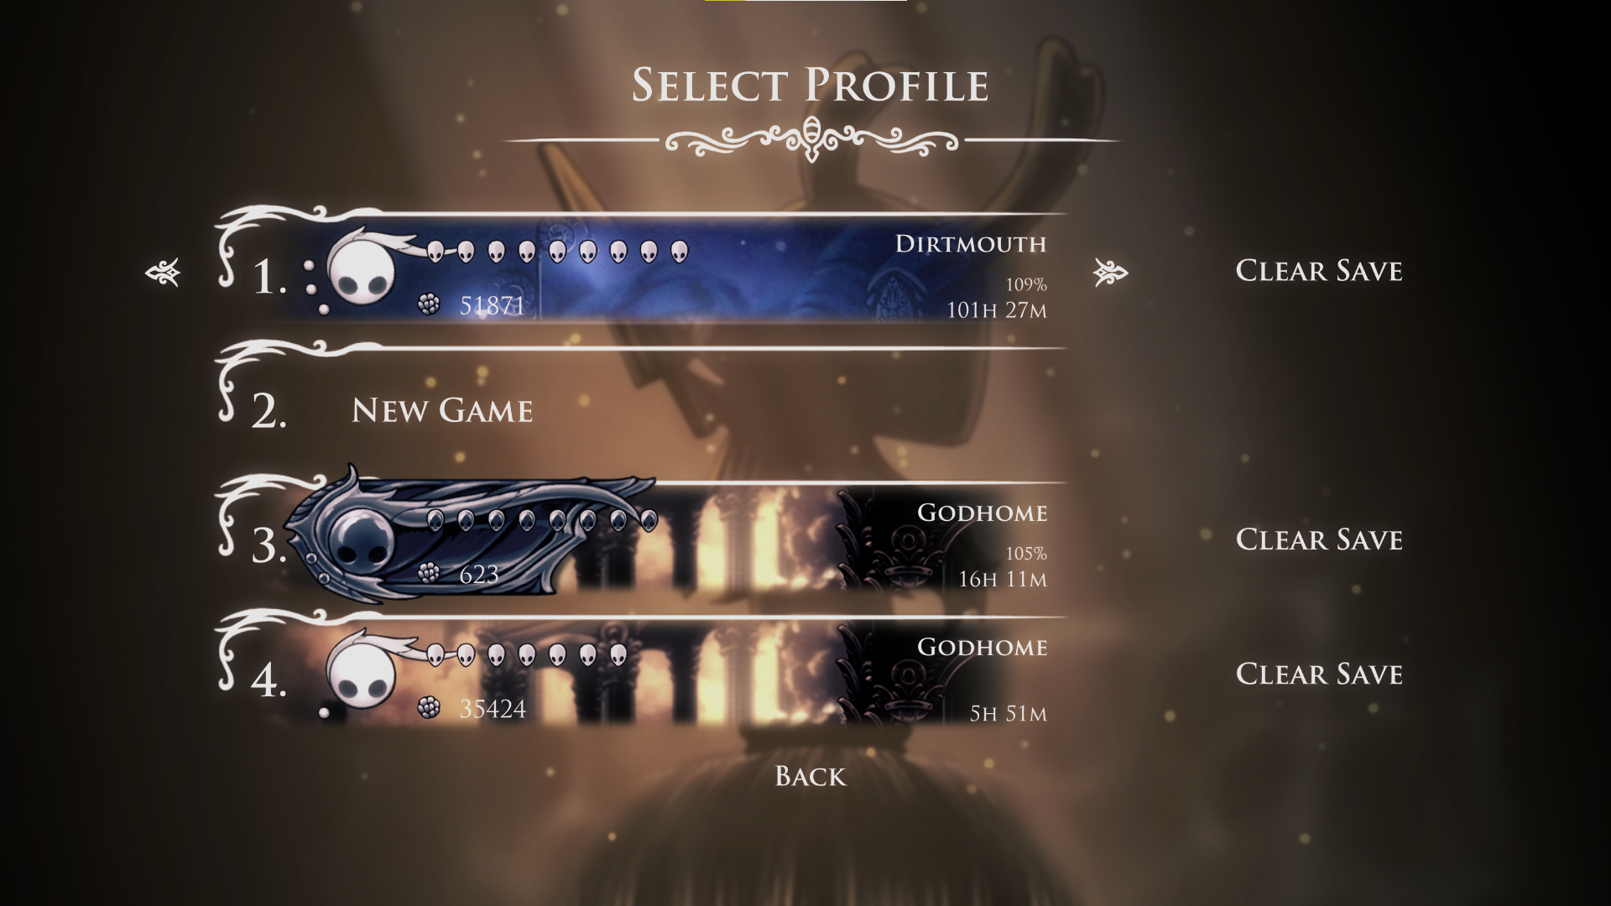

Figure : Screenshot taken by the author showing the save files

In **Figure 18** we can see that there are different layers to even a 2D game, this adds depth to a game where you can only move up down left and right as seen in **Figure 18** The background labelled **A** is the furthest back and will appear behind all other objects in the game. While the background labelled **B** is on top of **A** and will appear on top of that, the area labelled **C** is the plane that the player is on and can explore. The layer Labelled **D** is in front of the player Level and the player will be hidden behind objects that are on this layer. There is also a layer in front of **D** that is used occasionally.

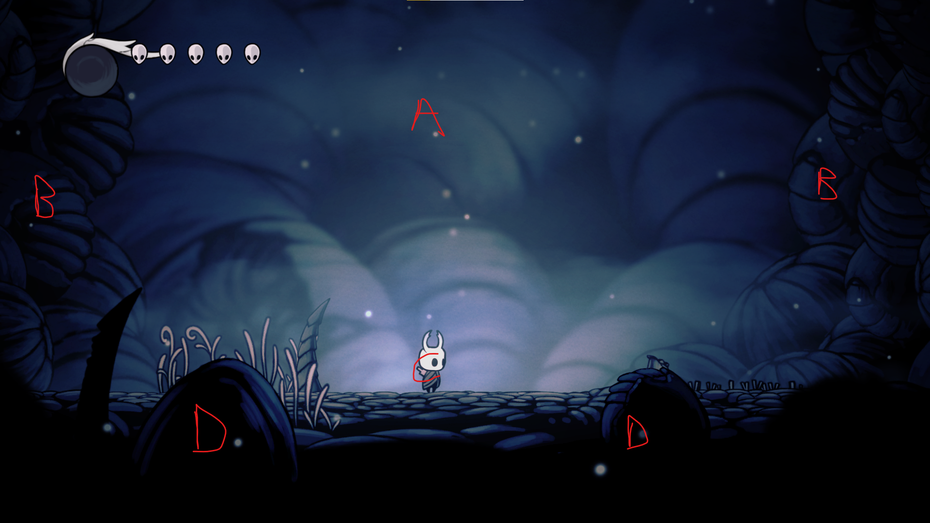

Figure : Screenshot taken by the author showing an example of how layers are used in Hollow Knight

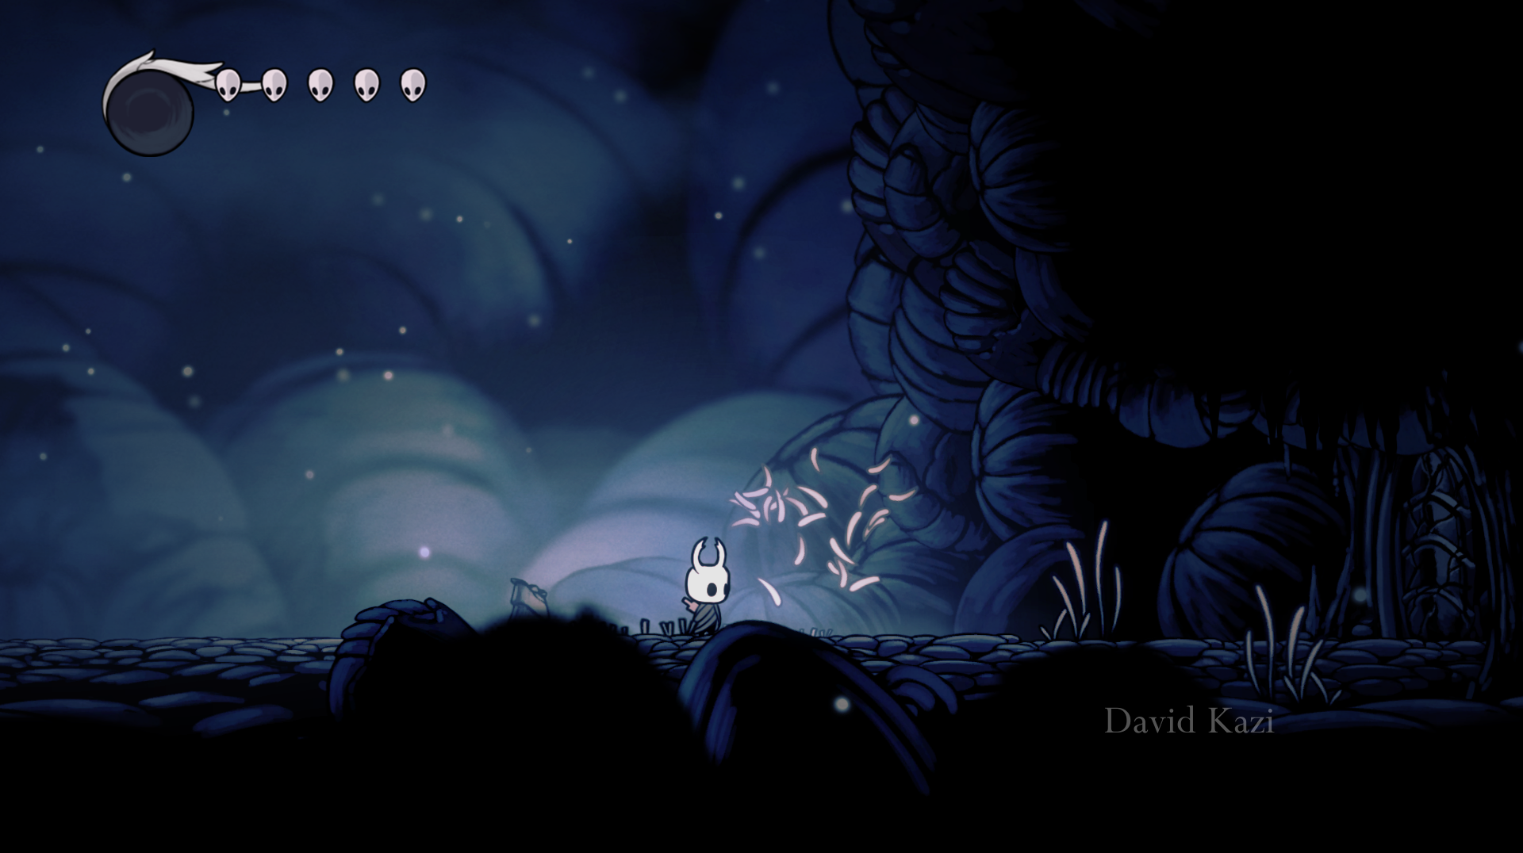 Figure : Showing interactable environment from Hollow Knight

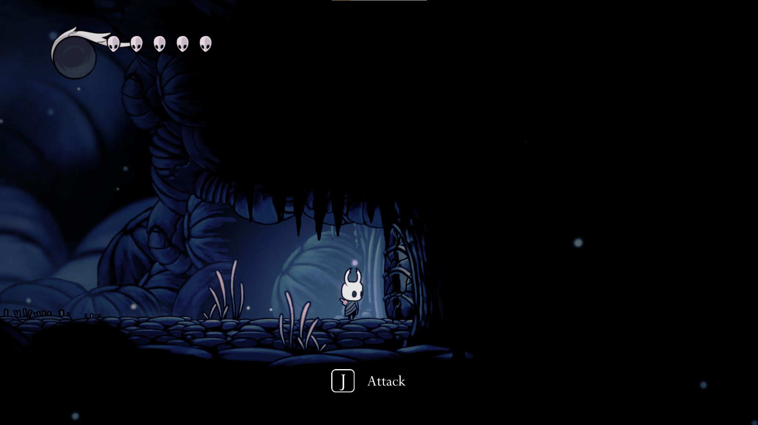

Figure : Showing interactable environment from Hollow Knight

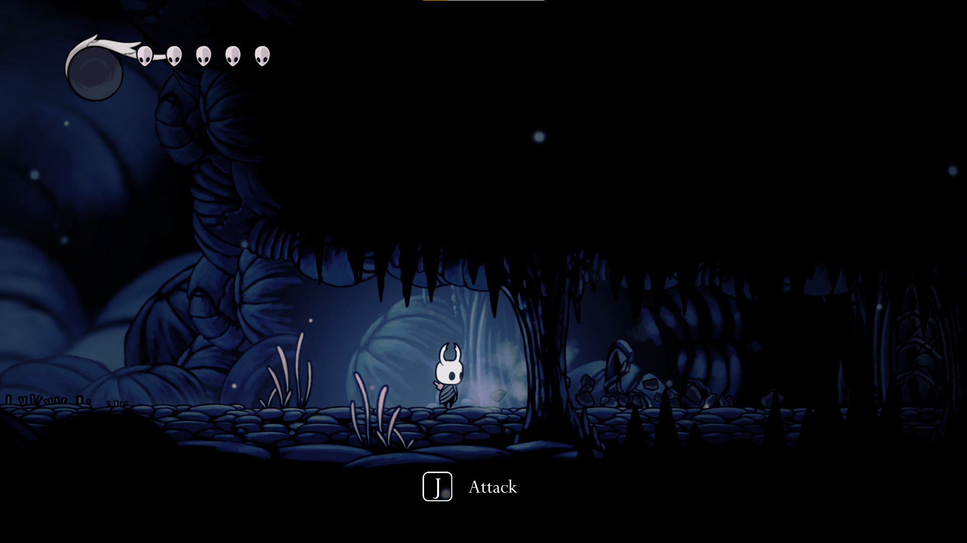

Figure : Showing interactable environment from Hollow Knight

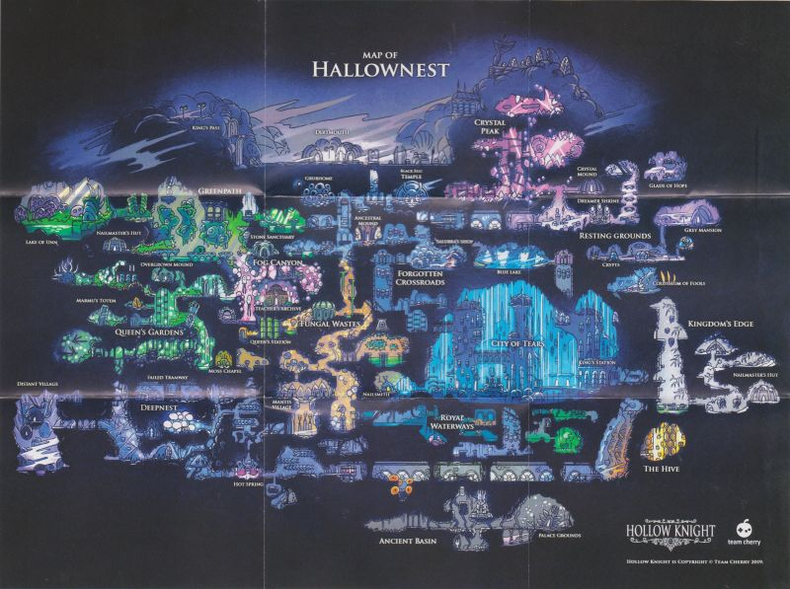

Figure : Full map of every area in Hollow Knight

## 4.3 Proposed Map Layout

## 4.3.1 The Crystal Village 1

In **Figures 23 – 24** the developed versions of The Crystal Village 1 are shown.

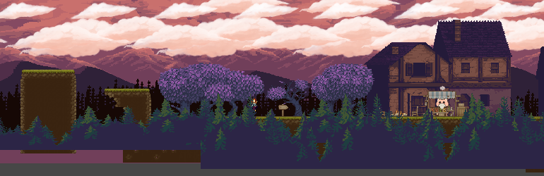

Figure The Crystal Village 1

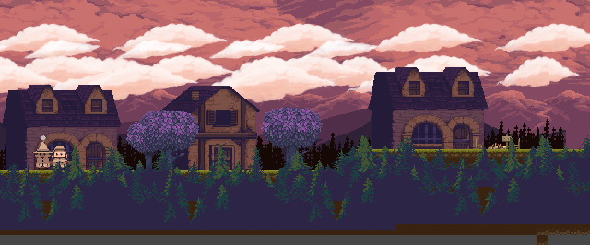

Figure The Crystal Village 1

## 4.3.2 The Crystal Village 2

In **Figures 25 – 26** the developed versions of The Crystal Village 2 are shown.

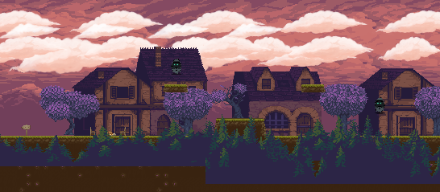

Figure The Crystal Village 2

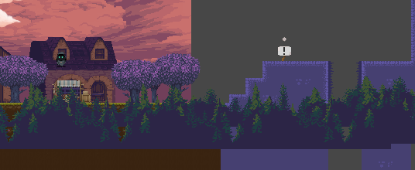

Figure The Crystal Village 2

## 4.3.3 The Crystal Mines

The **Figures 27 – 29** show the developed versions of the map.

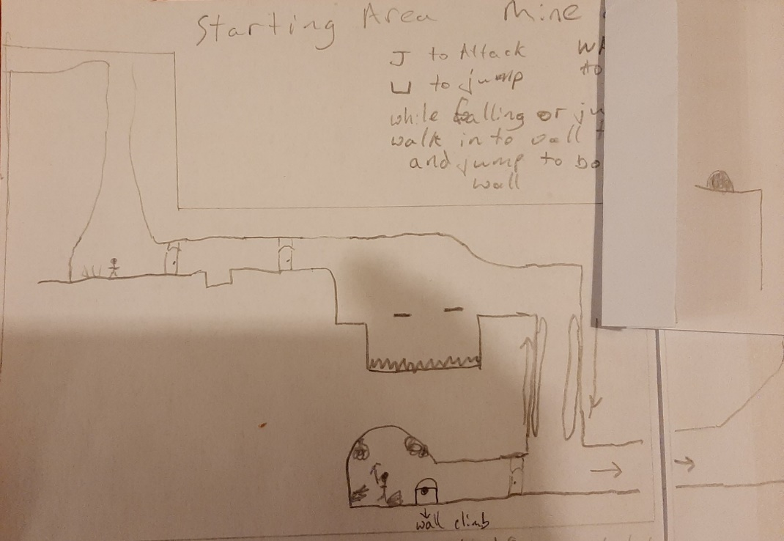

Figure Section 1 of The Crystal Mines

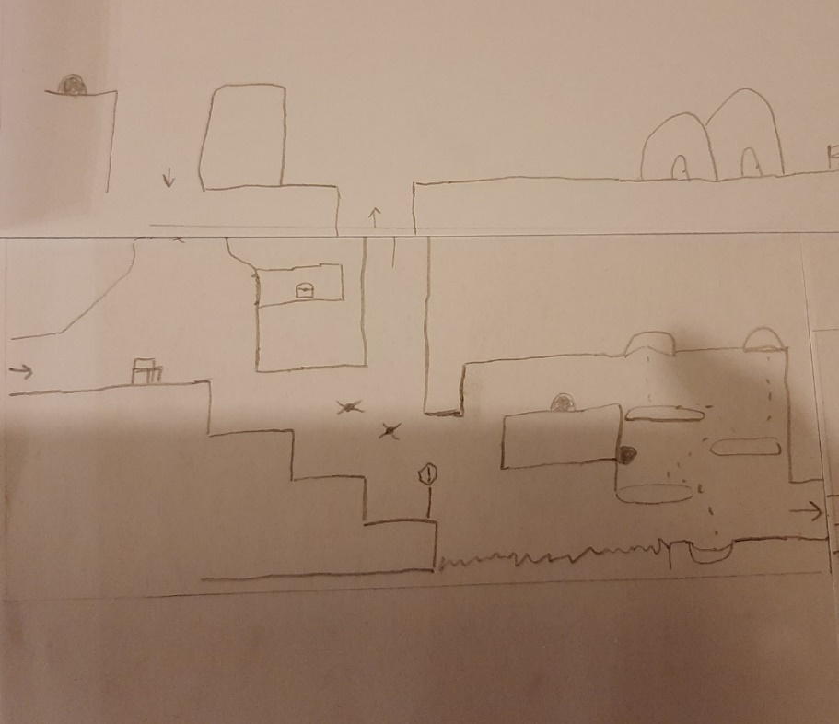

Figure Section 2 of The Crystal Mines

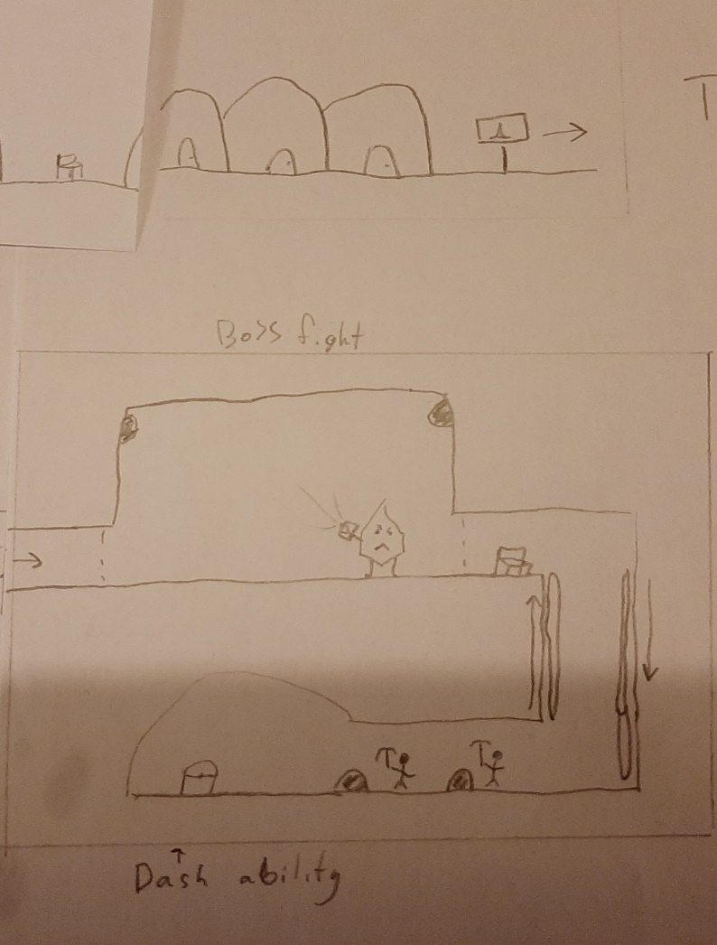

Figure Section 3 of The Crystal Mines

The **Figures 30 – 33** show the developed versions of the map.

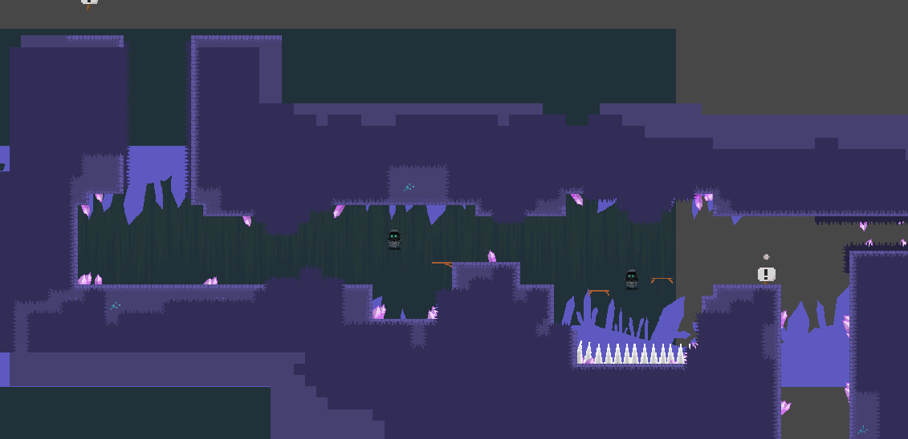

Figure Crystal Mines Section 1

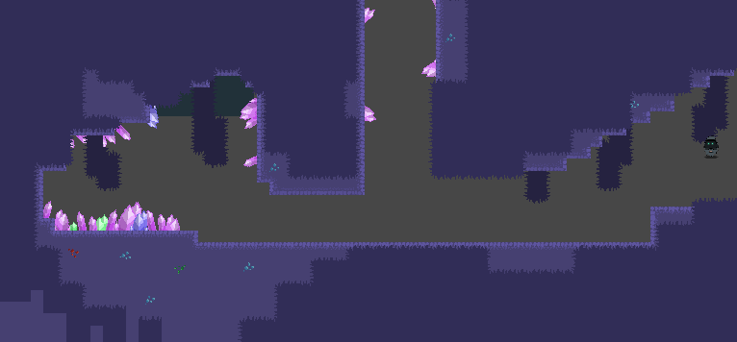

Figure Crystal Mines Section 2

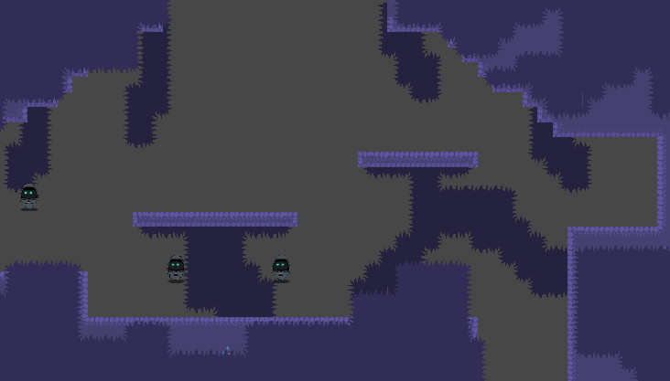

Figure Crystal Mines Section 3

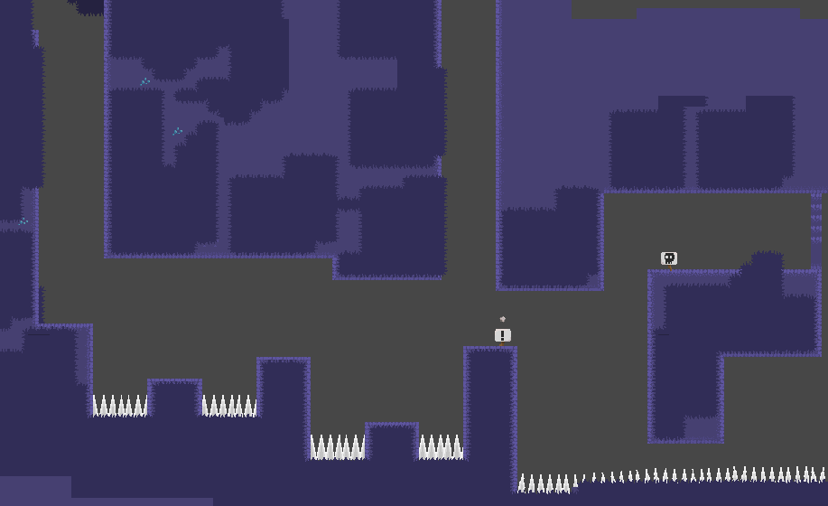

Figure Crystal Mines Section 4

## 4.3.4 The Crystal Mines Boss

The **Figure 34** shows the developed map of the crystal mine boss room.

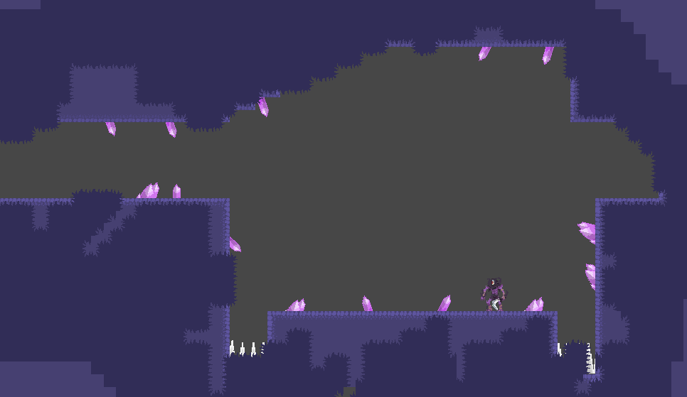

Figure Crystal Mines Boss